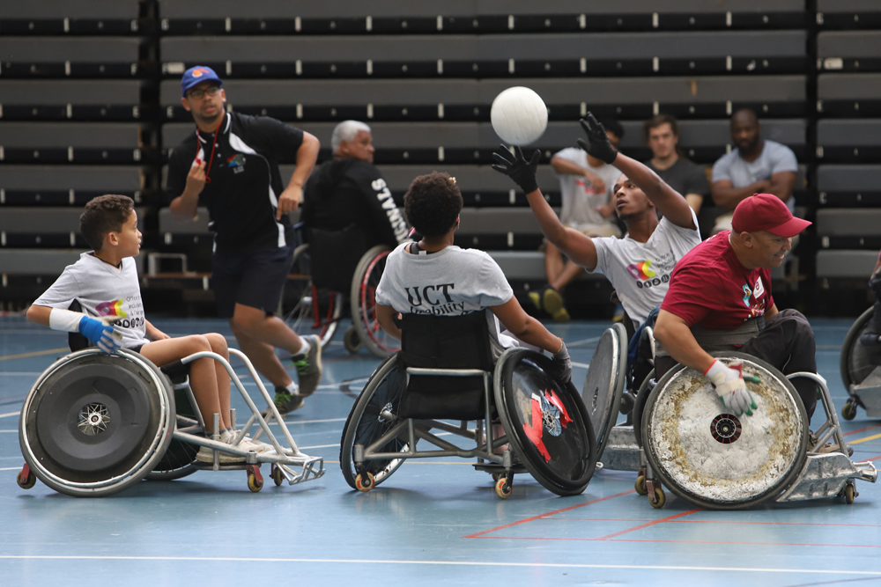

**For the athlete in all of us.**

**Do you remember that one coach who believed in you?** You know, the one who gave you courage, pushed you to be better than you ever thought you could, and shaped not only who you became as an athlete but your character as well. The skills and confidence that an athlete learns through sports have a long and lasting effect. Therefore, Beyond the Spectrum Sports is committed to supporting our coaches to be the best they can be. Our coaches challenge their athletes to improve every day, help them discover their strengths, and help them develop to their full potential.

Everyone should be able to use the same facilities, take part in the same activities, and compete at the same elite level. Our coaches strive to create an inclusive and challenging environment for all athletes, regardless of ability, so that each student athlete can address the skills they want to develop. Equity and inclusion are a priority at Beyond the Spectrum Sports. All practices and competitive events are designed around the equitable experiences and outcomes for all athletes with disabilities. In order to create the right conditions for learning, instruct in relevant skills, and prepare effective training programs, coaches evaluate each athlete based on individual performance. They encourage each athlete to develop advanced skill sets, awareness, and physical and mental fitness to reach their peak performance. Our coaches recognize each athlete's potential; enabling them to perform at the highest competitive levels. **Every athlete deserves a chance.** [Become a Coach.](mailto:beyondthespectrumsports@outlook.com)